**Steps for setup SSH**

**ssh-keygen -t ed25519 -C** [**juzarantri786@gmail.com**](mailto:juzarantri786@gmail.com)

* 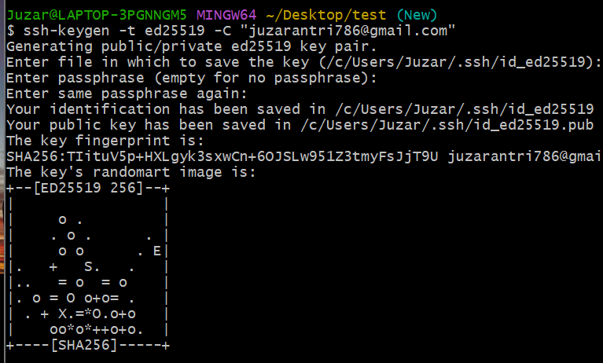Generating key from ssh-keygen. -t is there to specify encryption algorithm -C is for comment

**ls ~/.ssh**

* 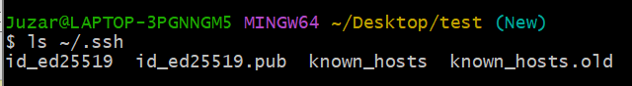Check if the key has been generated

**eval `ssh-agent -s`**

* This is used to start SSH agent through which we will add our SSH

**ssh-add ~/.ssh/id_ed25519**

* ****Adding SSH. This is done because every time when we interact with github it will not ask us for passphrase that we used at the time of generating SSH

**cat ~/.ssh/id_ed25519.pub**

* Diplaying the public key and copy that key to add in your github account.
* **For SSH commit signature add into**

your github account/setting/SSH and GPG keys/new SSH key/

type = any name

key type = Signing key

Key = paste the copied key

* **For accessing repository add into**

your github account/setting/SSH and GPG keys/new SSH key/

type = any name

key type = Authentication key

Key = same key which was copied

* 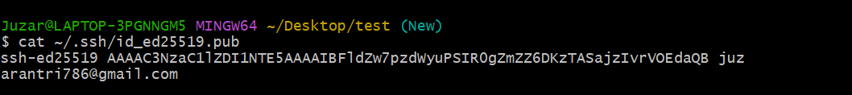**In our case we will add the key in both key type**

**ssh -T** [**git@github.com**](mailto:git@github.com)

* 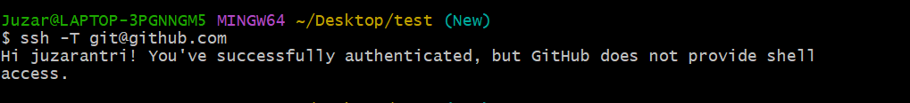Check for the connection it will show like below image if everything is correct

**Perform the commands:**

**git add .**

**git status**

**git commit -m "first commit"**

**git push origin New**

**git branch -l**

**git checkout New**

**git branch master**

**git checkout master**

**For any query contact Juzar Antri on Slack**